Name: SHABEEH UL HUSSAIN
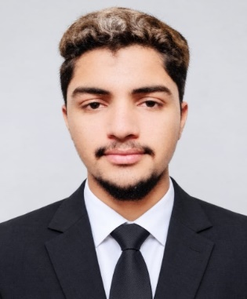
Father’s Name: Muhammad Sarwar
Gender: Male
Date of Birth: 31-12-2008
CNIC no: 31302-7710362-1
Nationality: Pakistani
Domicile: Rahim-Yar-Khan
Martial-Status: Singel
Academic Qualification:

Examination | Year | Marks | Percentage | Board/university
Matric | 2023 | 798/1100 | 72.54% | BISE BWP
Inter | 2025 | 779/1100 | 65.00% | BISE BWP
BS Software Engineering-1st year | 2026 | 1010/1200 | 84.17% | IUB BWP

Skills:
- Diploma Office Management (DOM)
- Computer Languages (Python, Html, Css)
Languages:
- Urdu
- Punjabi
- English (Normal)
Experience:
- Office Work
- Shop Keeper
Address:
- Bajwa Street no.2 Mohala Hakeem Abad Liaquat Pur District: Rahim Yar Khan
- Sadiq Egerton College Road Street no.1(Boys Hostel) Bahawal pur District: Bahawal pur
Contact:
- 0303-2561677
- 0315-6976896

